**System-User Manual**

**Version 1.0**

**Project Management App**

**Team A**

**CSC-355**

**Spring 2016**

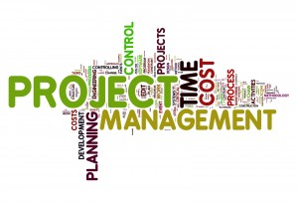

04/13/2016

Author: Jennifer Li – Project Leader

Submitted To: Dr. Joo Tan

**TABLE OF CONTENTS**

Revision History…………………………………………………………………………………..ii

1.0 Pre-Installation Requirements …..…..…..………….…...…………………………….……....1

2.0 Installation ………………...…..……………………………………………………………1-5

3.0 Using Project Management App ……………………………………………………………...6

3.1 Create an Account……………………………………………………………………..6

3.2 Login ………………………………………………………………………………….7

3.3 Create a Project ……………………………………………………………………….8

3.4 Add a Member ………………………………………………………………………..9

3.5 Accept Project Invitation ……………………………………………………………10

3.6 View all Members ……………………………………………………………….......11

3.7 Remove a Member …………………………………………………………………..12

3.8 Assign a Task ………………………………………………………………………..13

3.9 Submit a Task ……………………………………………………………………….14

3.10 Review a Task ……………………………………………………………………...15

3.11 View Calendar ……………………………………………………………………..16

3.12 View Overall Progress ……………………………………………………………..17

3.13 View Individual Progress ………………………………………………………......18

3.14 Choose a Role ……………………………………………………………………...19

3.15 Set a Reminder ……………………………………………………………………..20

3.16 Message a Member ………………………………………………………………...21

3.17 Logout ………………………………………………………………………….......22

**REVISION HISTORY**

|  |  |  |  |
| --- | --- | --- | --- |
| Version | Author | Description | Date |
| 1.0 | Jennifer Li | I created the first draft. | 01/31/2016 |
|  | Jennifer Li | Added Section 1, 2 and all of section 3. | 04/07/2016 – 04/13/2016 |
|  |  |  |  |

**1.0 PRE-INSTALLATION REQUIREMENTS**

Before installation of the Project Management app can begin, verify the following prerequisites are met:

1. System must run on Android
2. Must have a Google Play Account to utilize the Google Play Store
3. The minimum operating system need to run the application is Android 19

**2.0 INSTALLATION**

The following directions is an easy four step guide of how to install Team A’s Project Management application using an Android device.

**Step 1.** On your Android device click the Play Store icon to enter the Google Play Store as shown in image 1

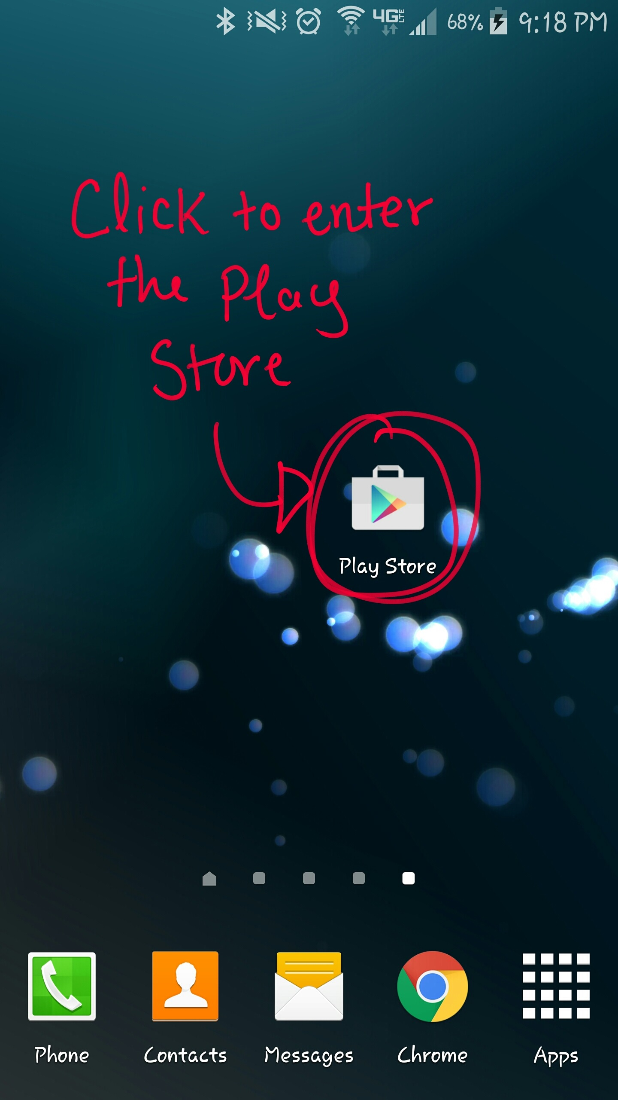

Image 1: Google Play Store Icon

**Step 2.** After entering the Play Store, type in “Kutztown Project Management” in the search bar shown in image 2 or click on the link down below to be directed to the application.

Link: <https://play.google.com/store/apps/details?id=com.kutztown.project.projectmanagement>

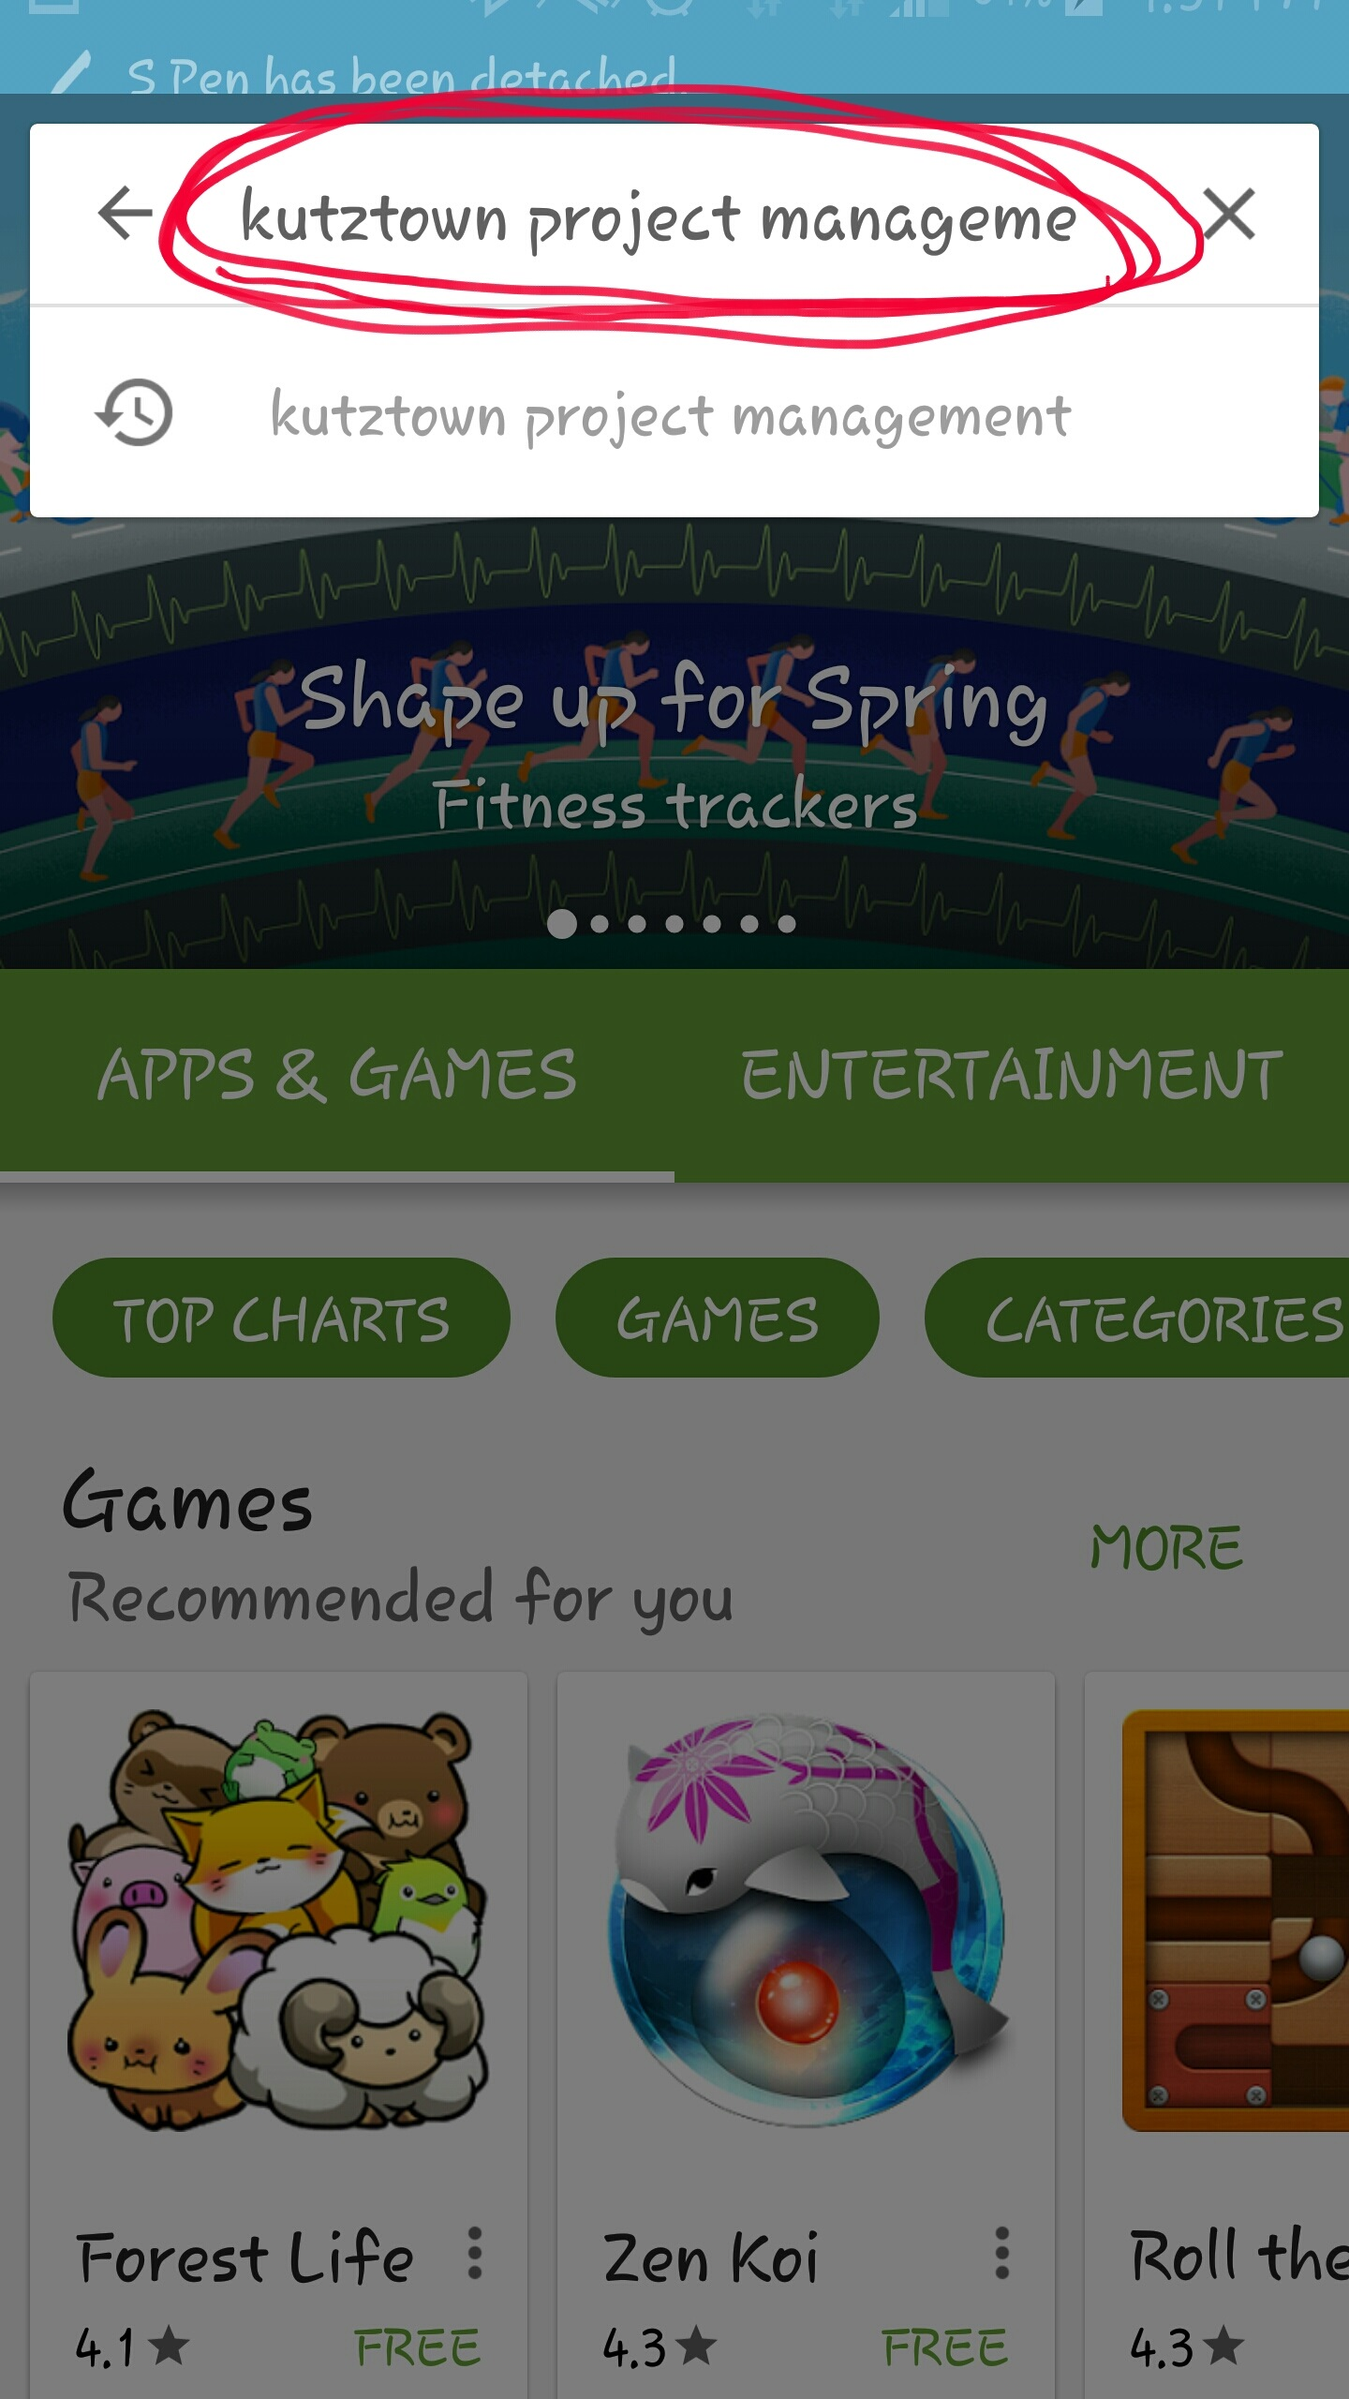

Image 2: Search Bar containing “Kutztown Project Management”

The application’s Icon has the letters “PM” in white with a blue background shown in image 3

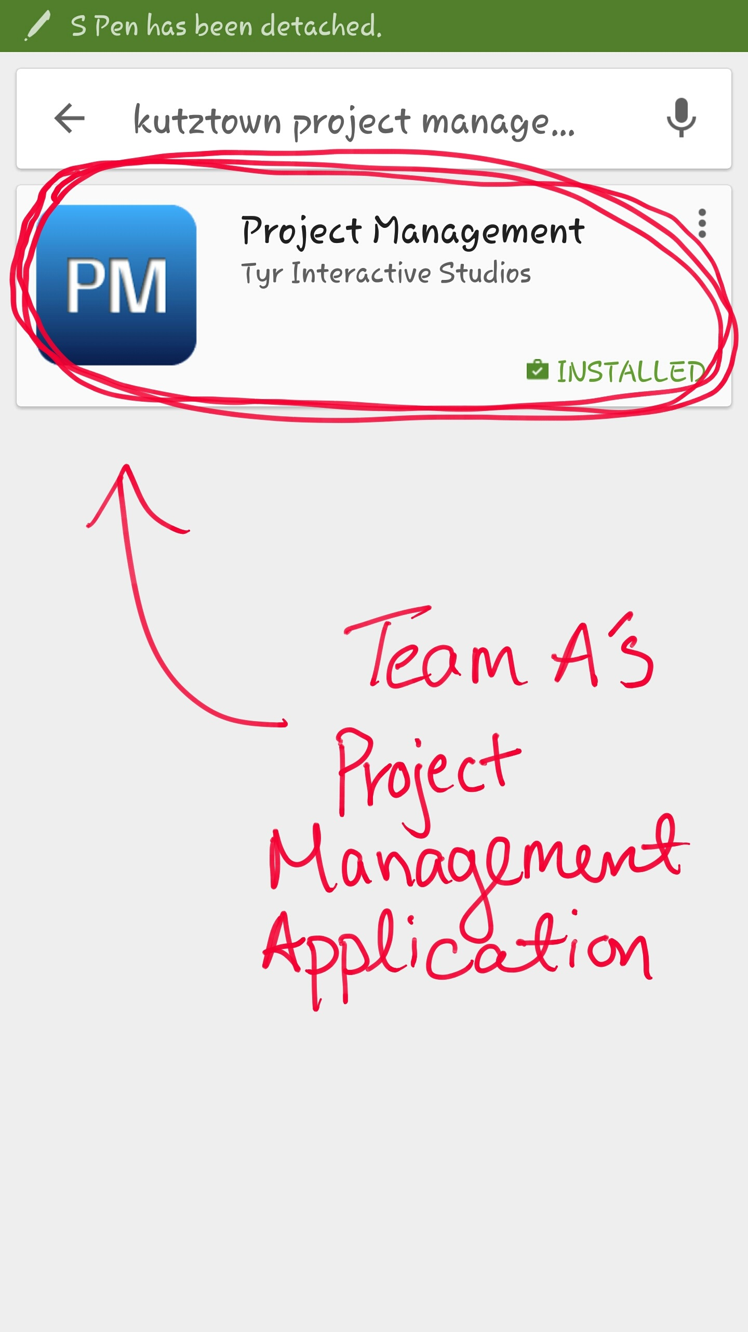

Image 3: Project Management Icon

**Step 3.** Select the Project Management application. You will be directed to the application’s installation page. Click the “INSTALL” button as shown in image 4.

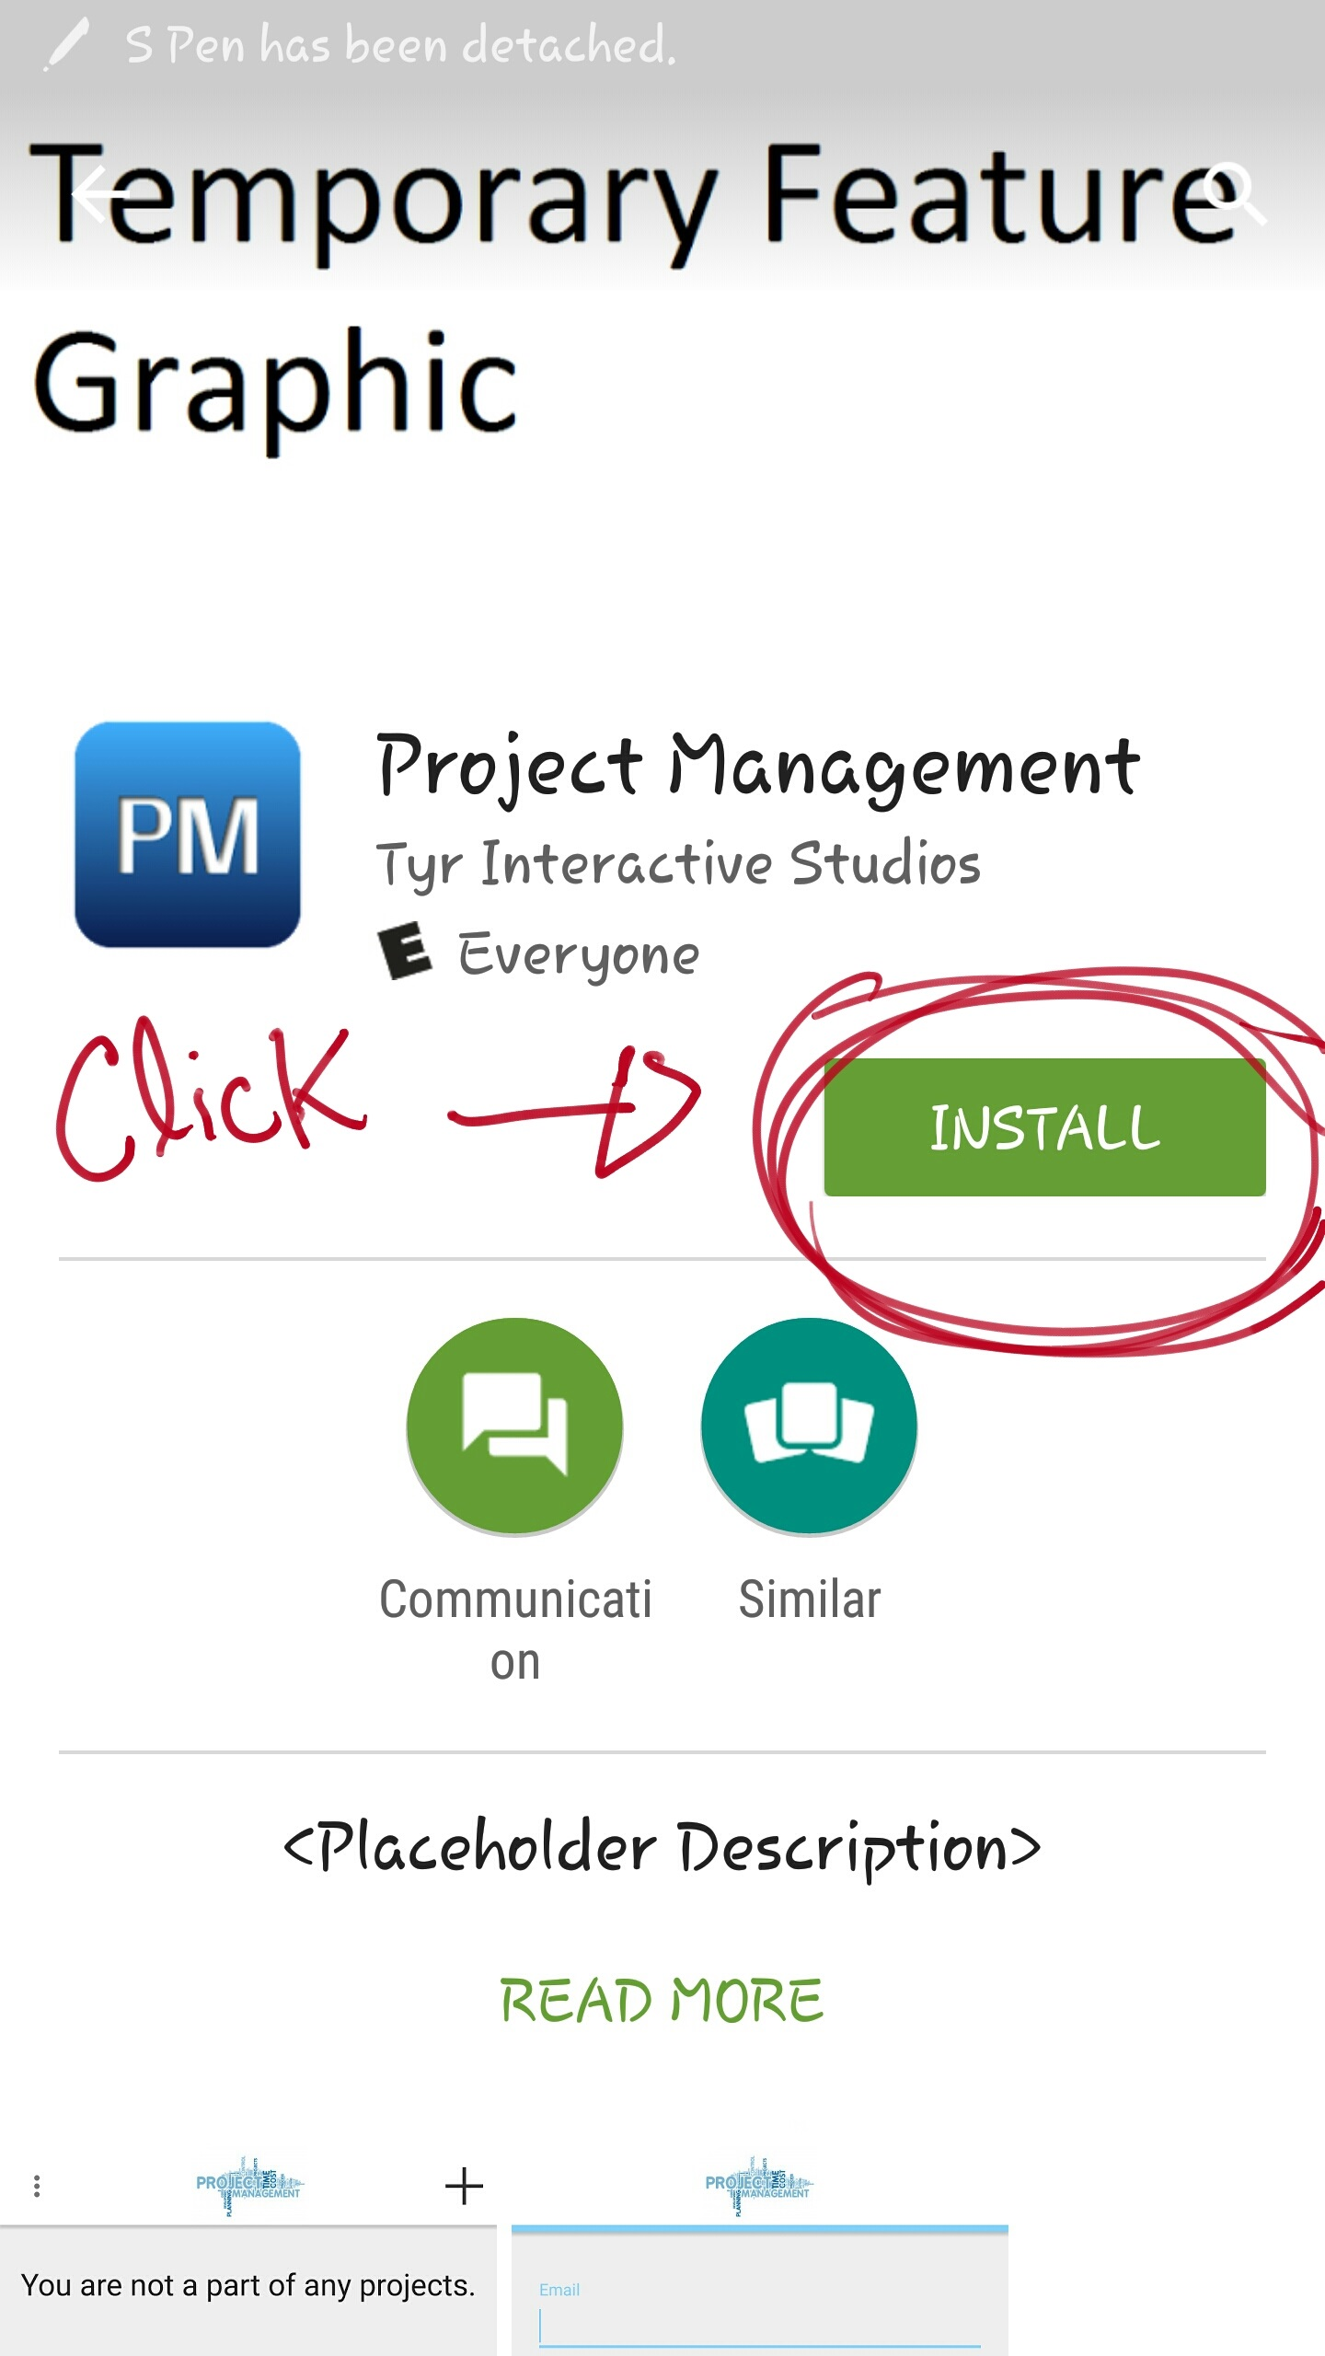

Image 4: Installation button on the application’s installation page

**Step 4.** Accept all of the application’s needs to access and wait for the application to install on your android device. Once the application has properly installed, click the “OPEN” button shown in image 5.

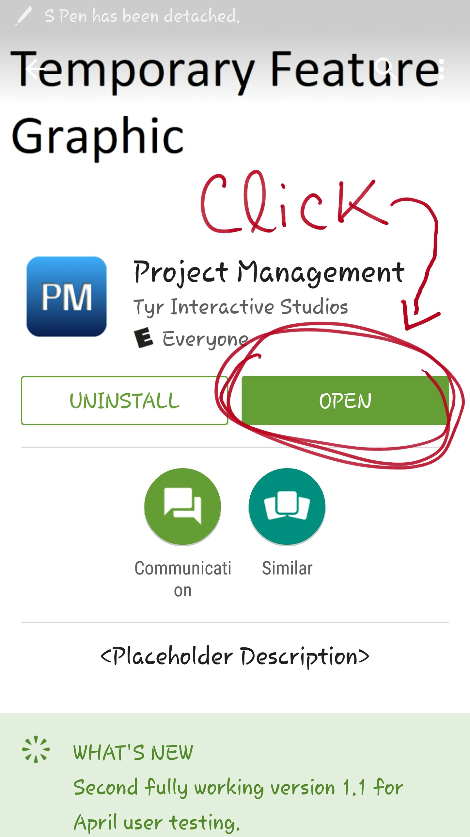

Image 5: Open button is available only after proper installation

Congratulations! You have successfully installed Team A’s Project Management application!

**3.0 USING PROJECT MANAGEMENRT APP**

The following sections will be a simple guide of the basic functionality of the Project Management App. The apps functionality consist of, creating an account, logging in, creating a project, adding members, accepting project invitations, viewing all added members, removing members, assigning task, submitting completed task, reviewing the submitted task, viewing the calendar, viewing the overall progress, viewing individual progress, choosing a role, setting reminders, and messaging.

3.17 Logout

**3.1 Create an Account**

To create an account you must first register. All you need to do to register in this application is to enter your “Email” and “Password” in the provided fields. The entered email must be a valid email and the password must be longer than four characters. After all the fields are filled out, click the “REGISTER” button to create an account as shown in image 6.

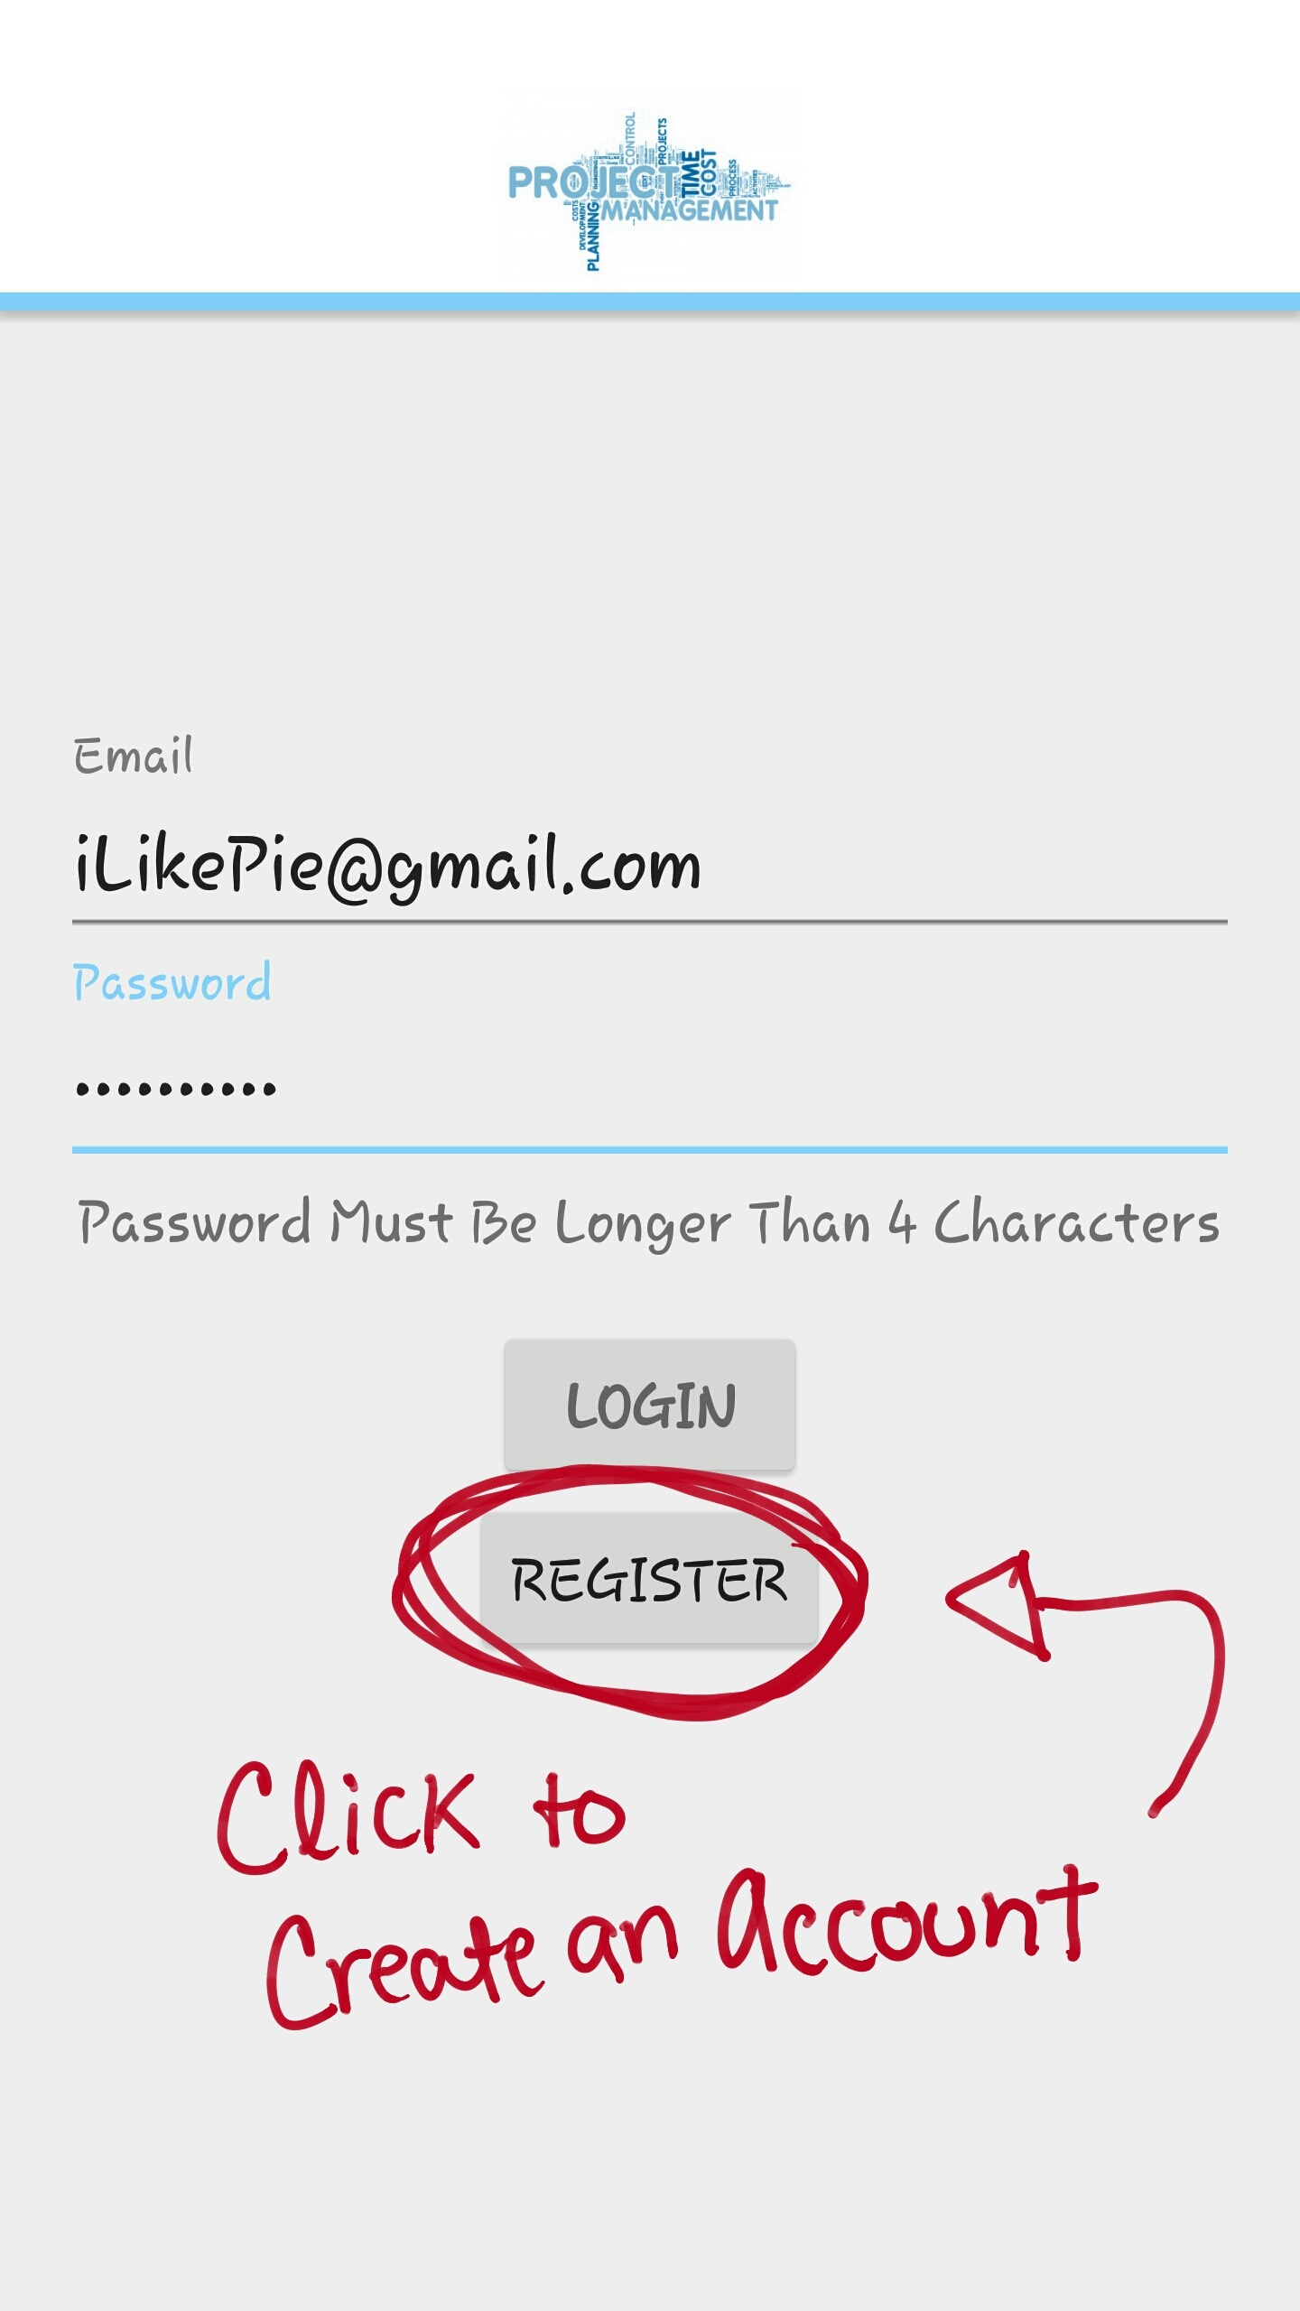

Image 6: Once Email and Password fields are filled out, register

**3.2 Login**

To login to the application, all you need to do is to enter your Email address and the correct password that you created. Once both fields are filled out, click the “LOGIN” button to access your account like shown in image 7.

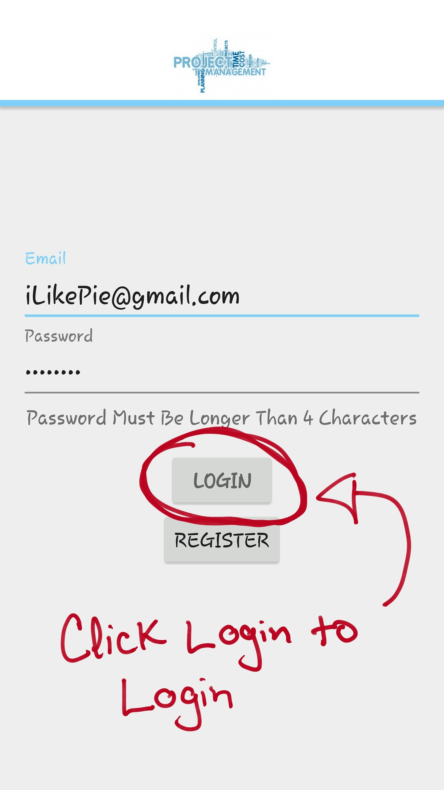

Image 7: Once Email and Password fields are filled out, login

**3.3 Create a Project**

After you have logged in to the application, click the “**+**” sign to create a project. Once the “**+**” is clicked, you will be directed to the create a project screen. There you will fill out the “Project Name” and “Project Description” fields. Once the fields are filled out click the “CREATE” button to create the project as shown in image 8.

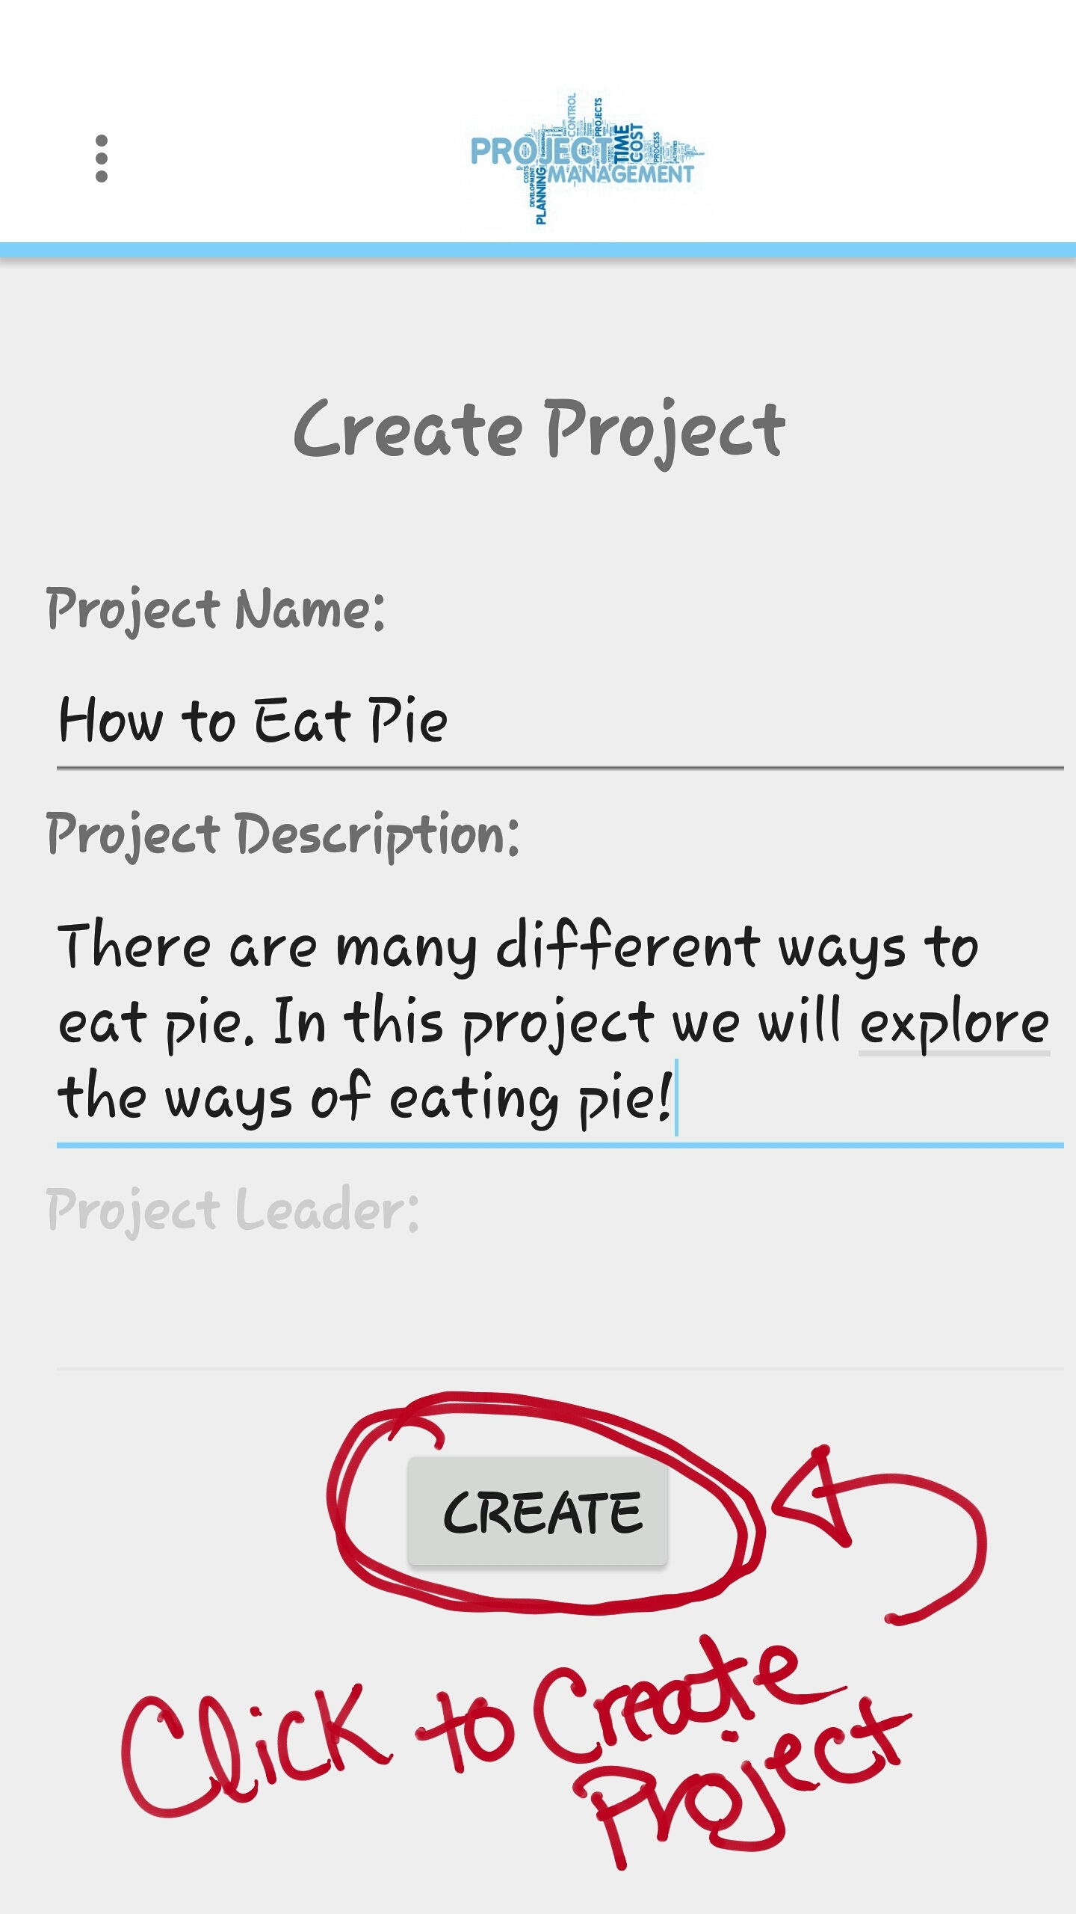

Image 8: Once “Project Name” and “Project Description” fields are filled out, create the project

**3.4 Add a Member**

Once you have logged in and created a project; as the leader, the next step is to add a member to the project. To add a member to a project, click the “MEMBERS” button at the bottom right of the project view screen. You will then be directed to the member list view screen; there you will click the “**+**” sign. The “**+**” sign will direct you to the list of all members that have register in the database. Select the member you would like to join your project. Once the member is selected, you will be prompted to choose a mail client to email an invitation to the selected member as shown in image 9. After selecting a mail client, you will be directed to that mail client’s compose an email screen. There you will hit the send button to send the invitation out to the desired member.

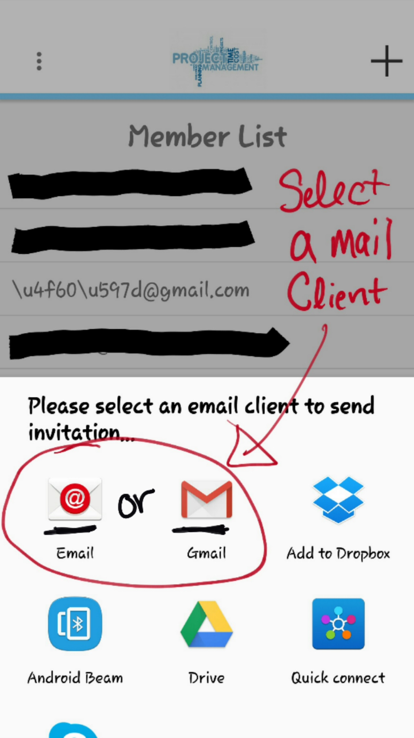

Image 9: Android prompt user to select a mail client

**3.5 Accept Project Invitation**

The invited member should have a pre-existing account to be able receive invitations to a project. If you have been invited to join a project by the use of the Project Management app; you must first check your email to see if the invitation has been received. The sender of the email should be the name of the project leader that invited you to the project. Open up that email and click the link that has been provided. That link will take you to the web service that handles project invitations. If the web service displays a “1” you have been added into the project as shown in image 10.

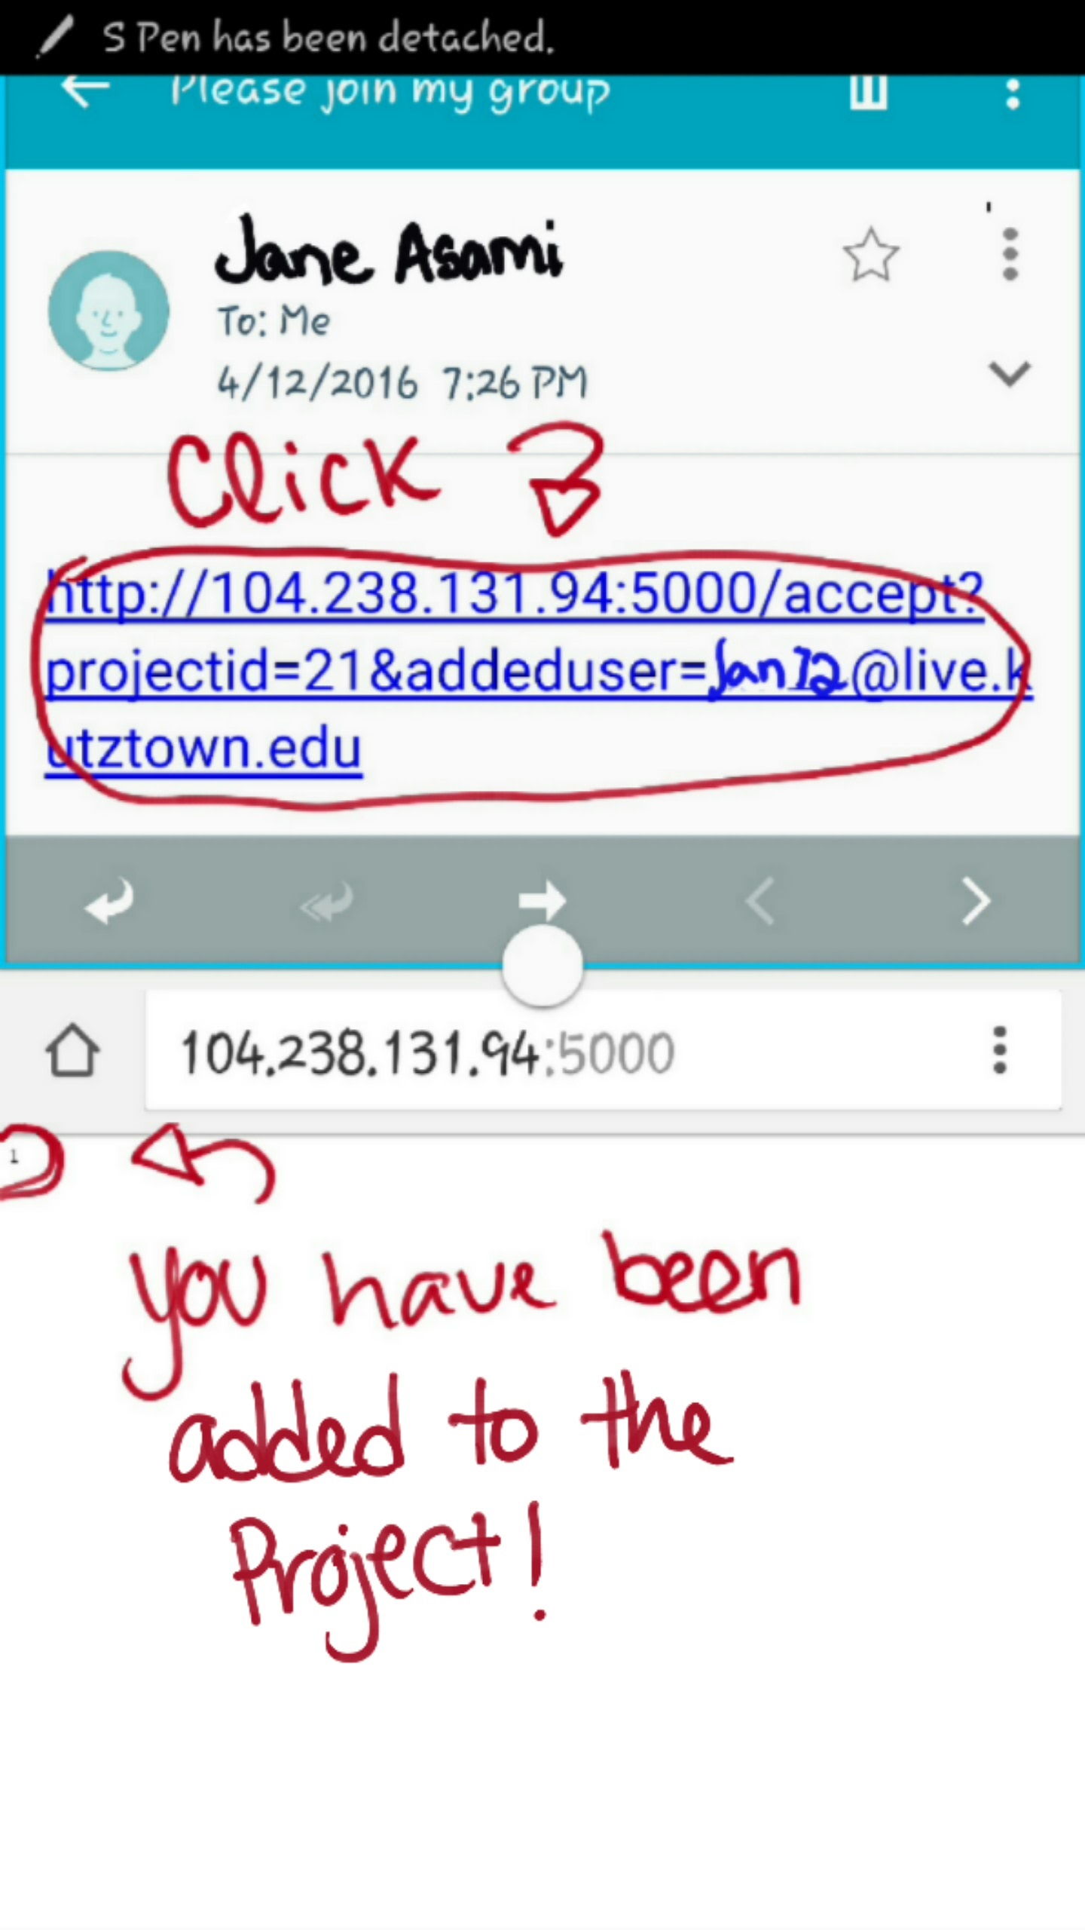

Image 10: Invitation has been received and user has been successfully added to the project

**3.6 View all Members**

To view all members associated to a project, you have to be logged in and be a part of a created project. Once those requirements are met, click the “MEMBERS” button at the bottom right of the project view screen. You will then be directed to the Member list view screen that is shown in image 11.

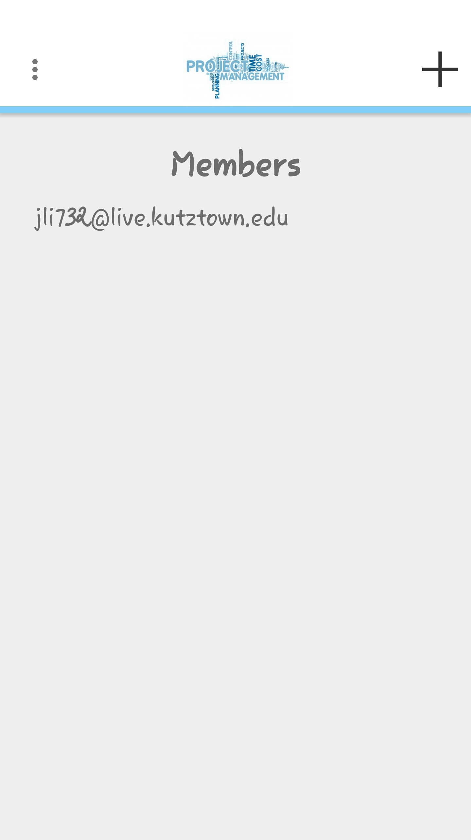

Image 11: The list of all members in the example project

**3.7 Remove a Member**

To remove a member associated with a project, you have to be logged in and the leader of the created a project. Once those requirements are met, click the “MEMBERS” button at the bottom right of the project view screen. You will then be directed to the Member list view screen, select the member you would like to remove from the project by holding the click until you are prompted to remove the selected member. Next slide your finger over to the prompt and select “YES” to remove the member as shown in image 12.

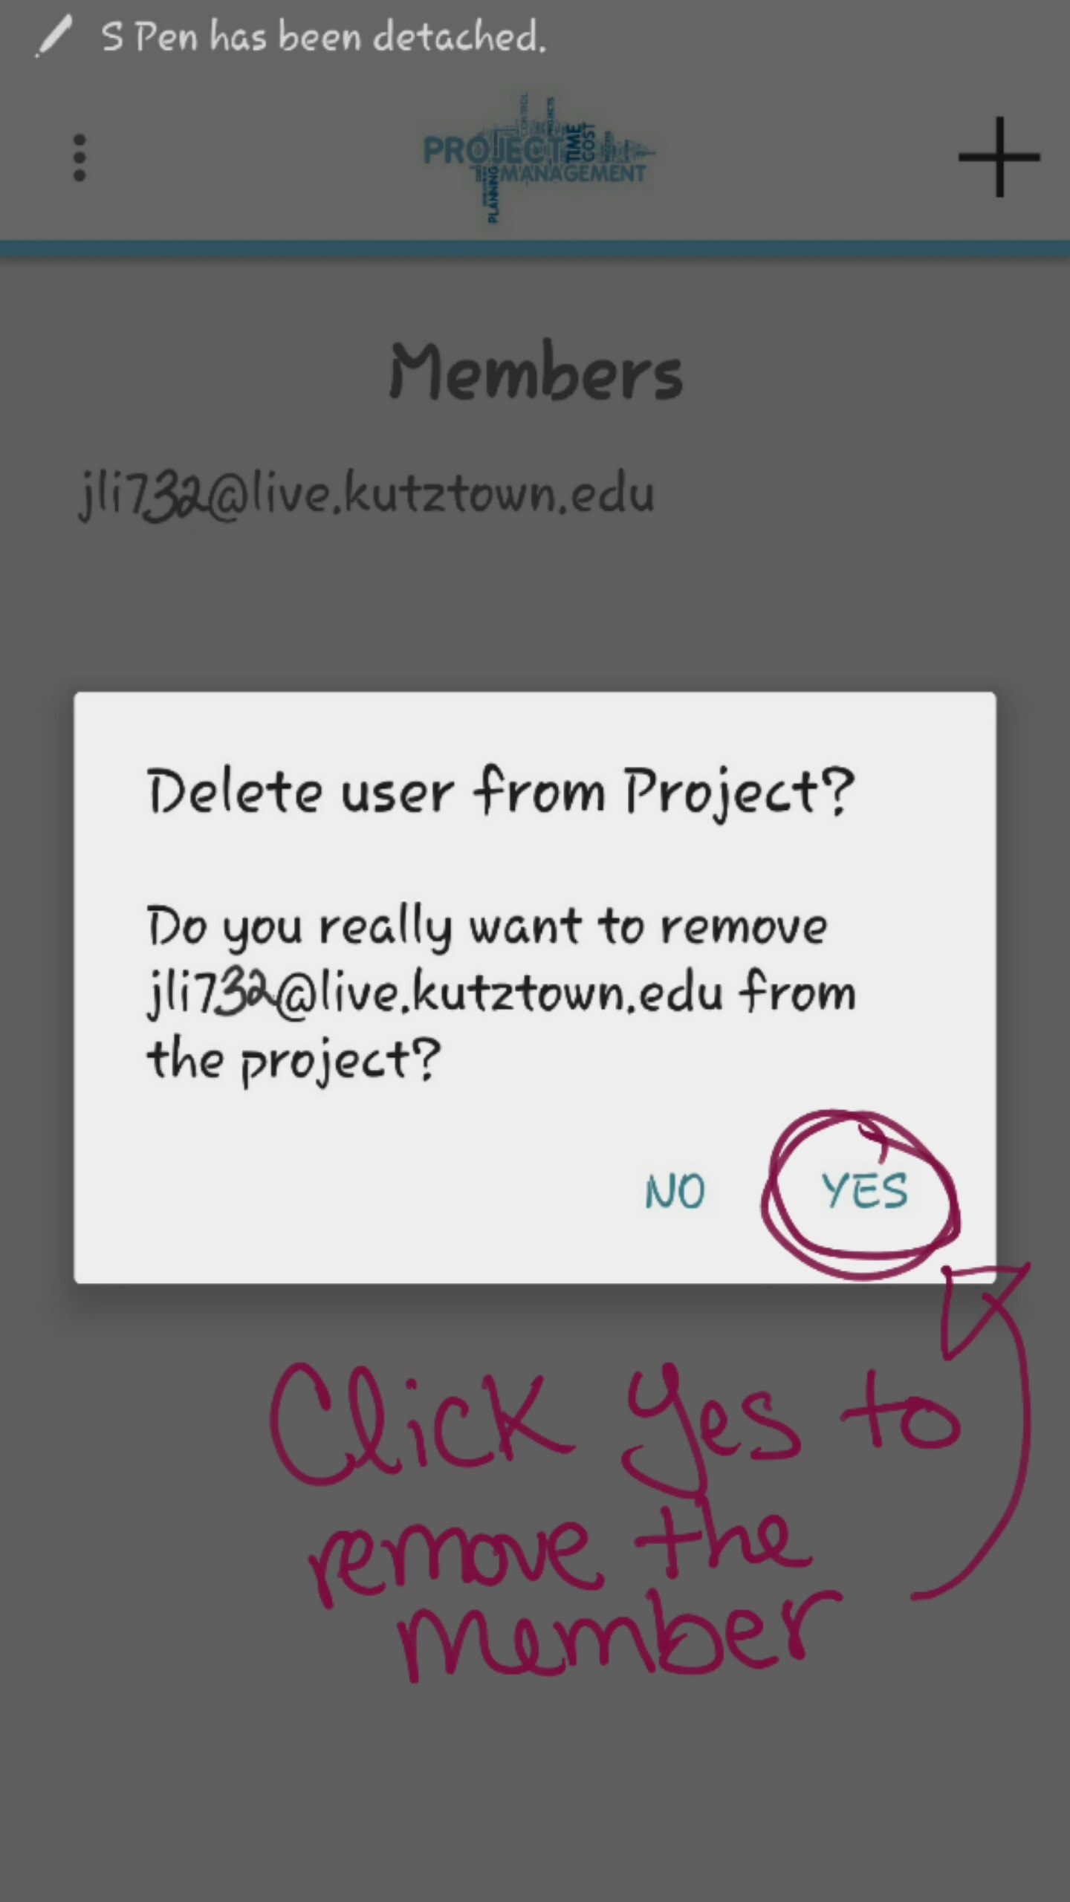

Image 12: Leader removing a member of the project

**3.8 Assign a Task**

Once you have logged in and have member(s) in a created project; as the leader, the next step is to assign task(s) to member(s). To assign task, click the “TASK” button at the Top right of the project view screen. You will then be directed to the task list view screen; there you will click the “**+**” sign. The “**+**” sign will direct you to create a task screen, there you will fill out the necessary fields and choose a due date as shown in image 13. Once done hit create a task to be directed back to the task list view screen.

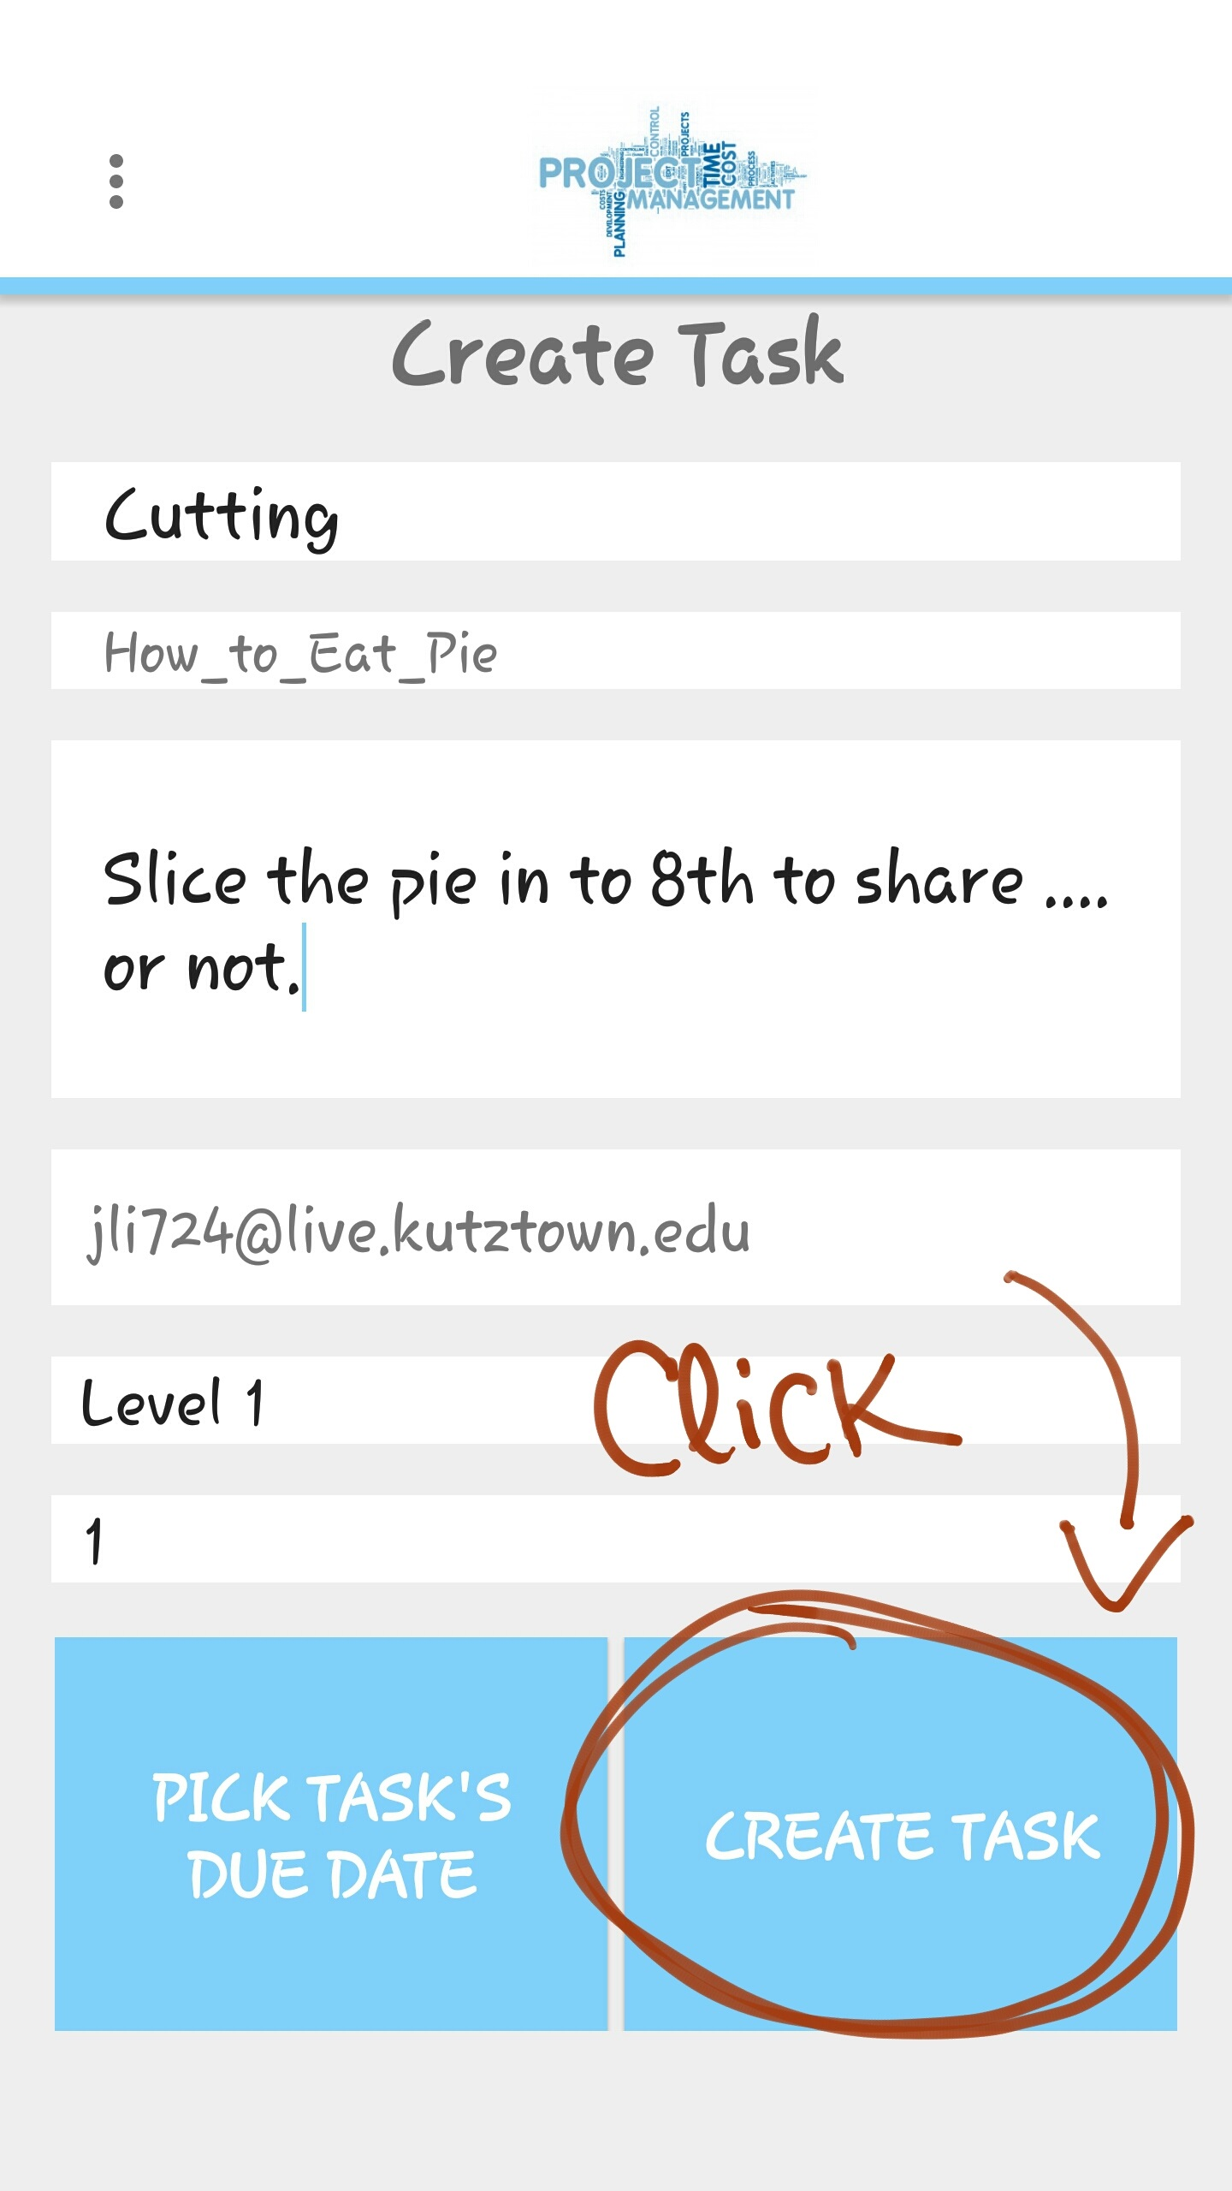

Image 13: Leader has filled out the necessary fields and ready to create the task

**3.9 Submit a Task**

To submit a task, you must be a member of the specific project. If you are a member and have been assigned a task, click the “TASK” button at the Top right of the project view screen. You will then be directed to the task list view screen; there you will select the specific task assigned to you. Preform the task and move the percentage bar to 100% to complete the task and click the “SUBMIT” button as shown in image 14.

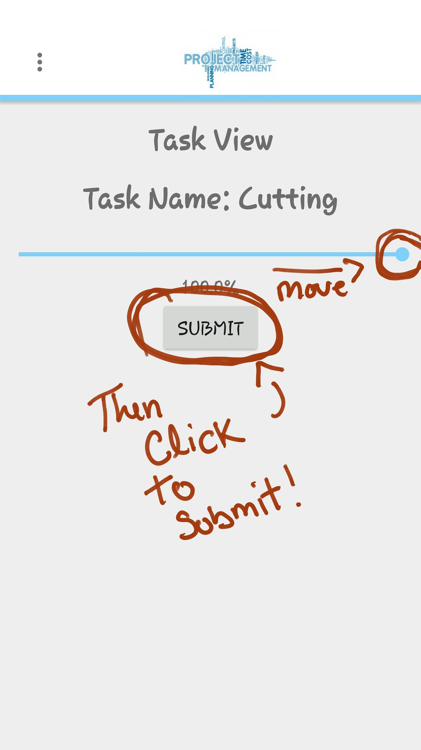

Image 14: The task Cutting has been competed by member Jane and will be submitted for review

**3.10 Review a Task**

To review a task, you must be the leader of a specific project with completed task(s). If you are the leader and have a completed task in your project, click the “TASK” button at the Top right of the project view screen. You will then be directed to the task list view screen; there you will select the completed task(s) under the “Completed Tasks” section of the list. Select a specific task for review. If the task is complete leave the percentage bar be and return to the task list view screen. If the completed task is not up to your standards move the progress bar to a desired percentage and hit update as shown in image 15.

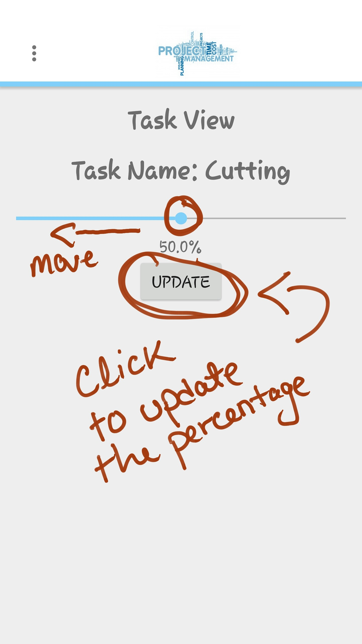

Image 15: Leader has reviewed the completed task not up to standard

**3.11 View Calendar**

To view the calendar of the specific project you must be logged in and be a part of a created project. Once those requirements are met, Click the “CALENDAR” button at the middle right hand side in the project view screen as shown in image 16. You will then be directed to the calendar view specific to your phone.

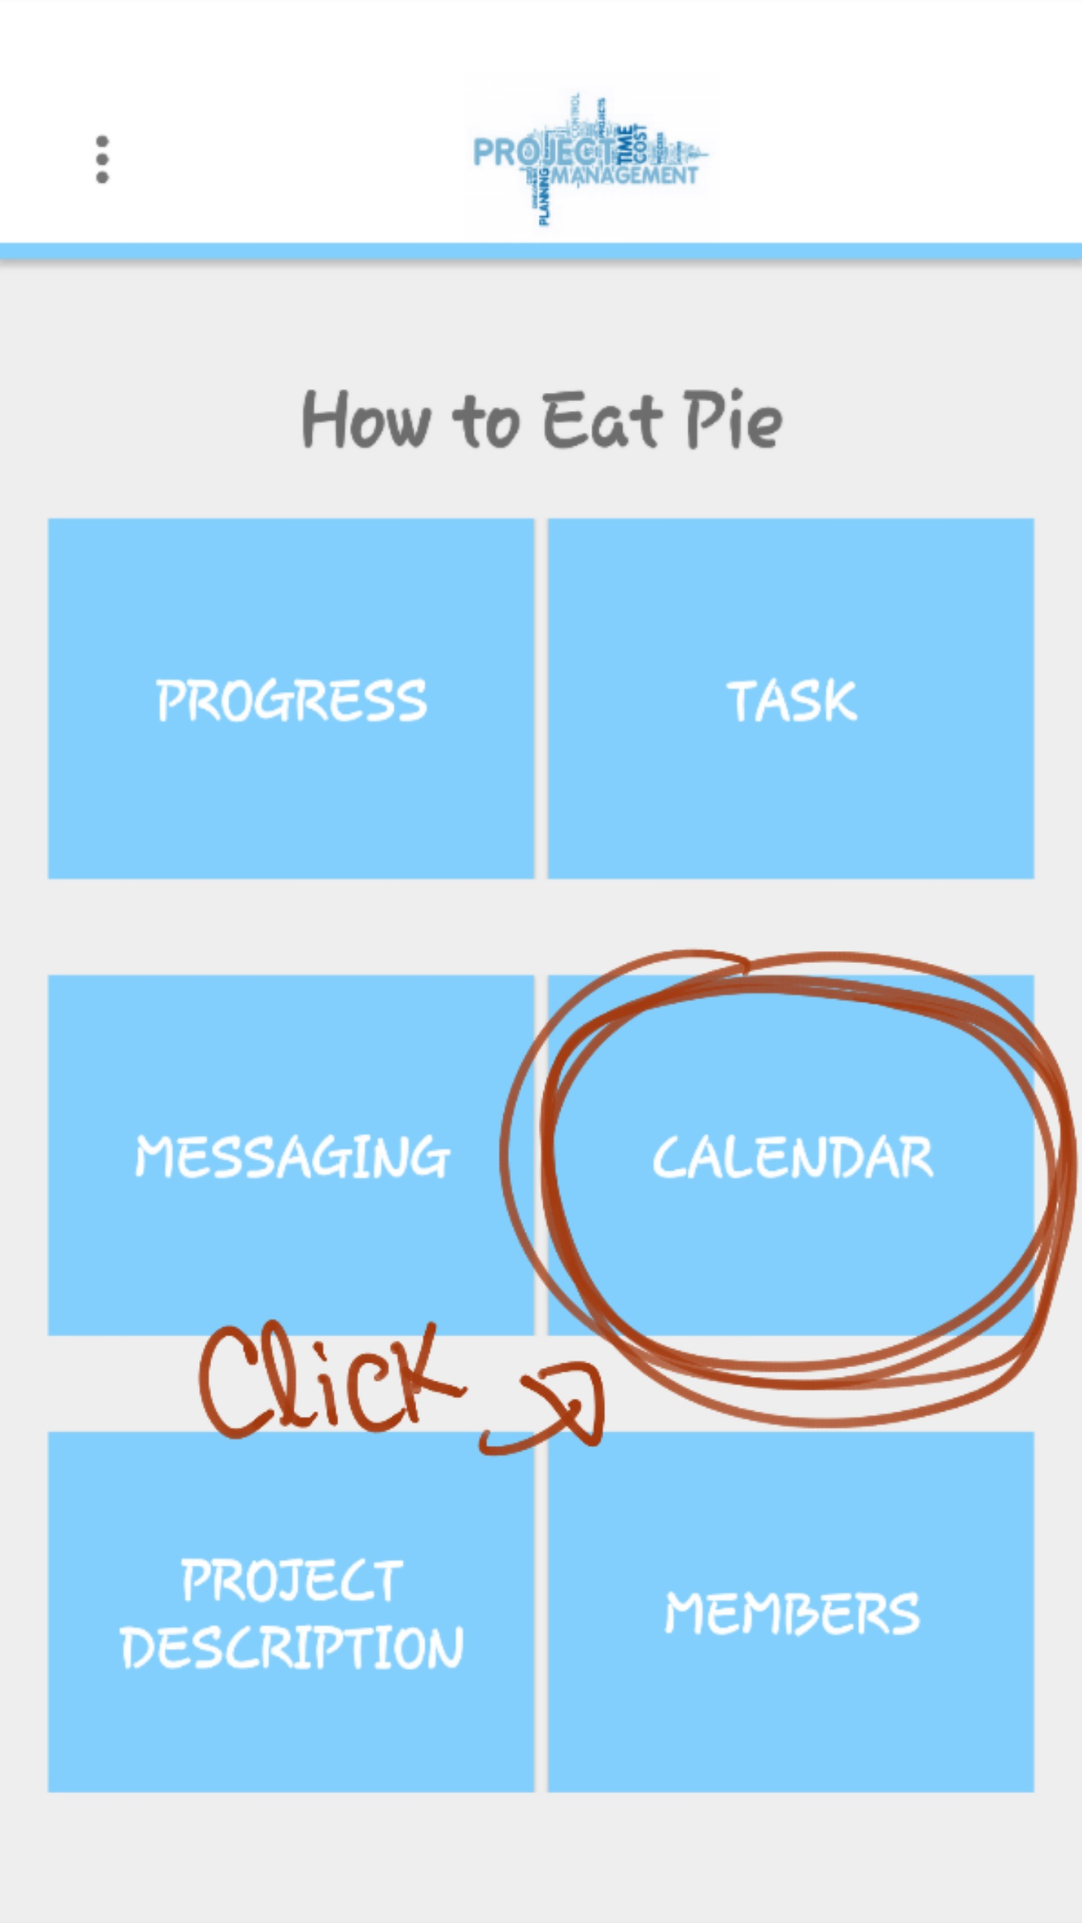

Image 16: The location of the “CALENDAR” button in the project view

**3.12 View Overall Progress**

To view the overall progress of the specific project you must be logged in and be a part of a created project. Once those requirements are met, Click the “PROGRESS” button at the top left hand side in the project view screen. Once clicked, you will be directed to the overall progress screen as shown in image 17.

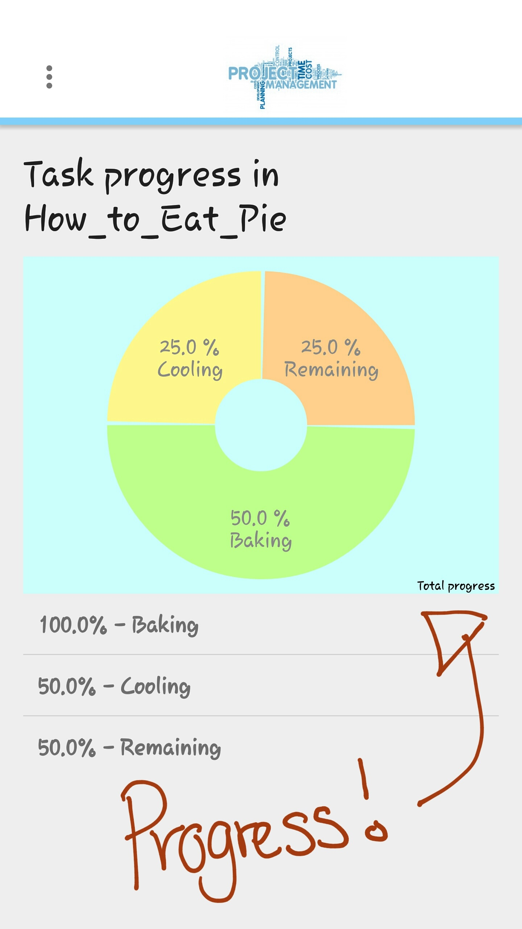

Image 17: The overall progress of the example project

**3.13 View Individual Progress**

To view individual progress of the specific project or task, you must be logged in and be a part of a created project. Once those requirements are met, click the “MEMBERS” button at the bottom right of the project view screen. You will then be directed to the Member list view screen, select the member you would like to view his/her progress. You then will be directed to that member’s individual progress as shown in image 18.

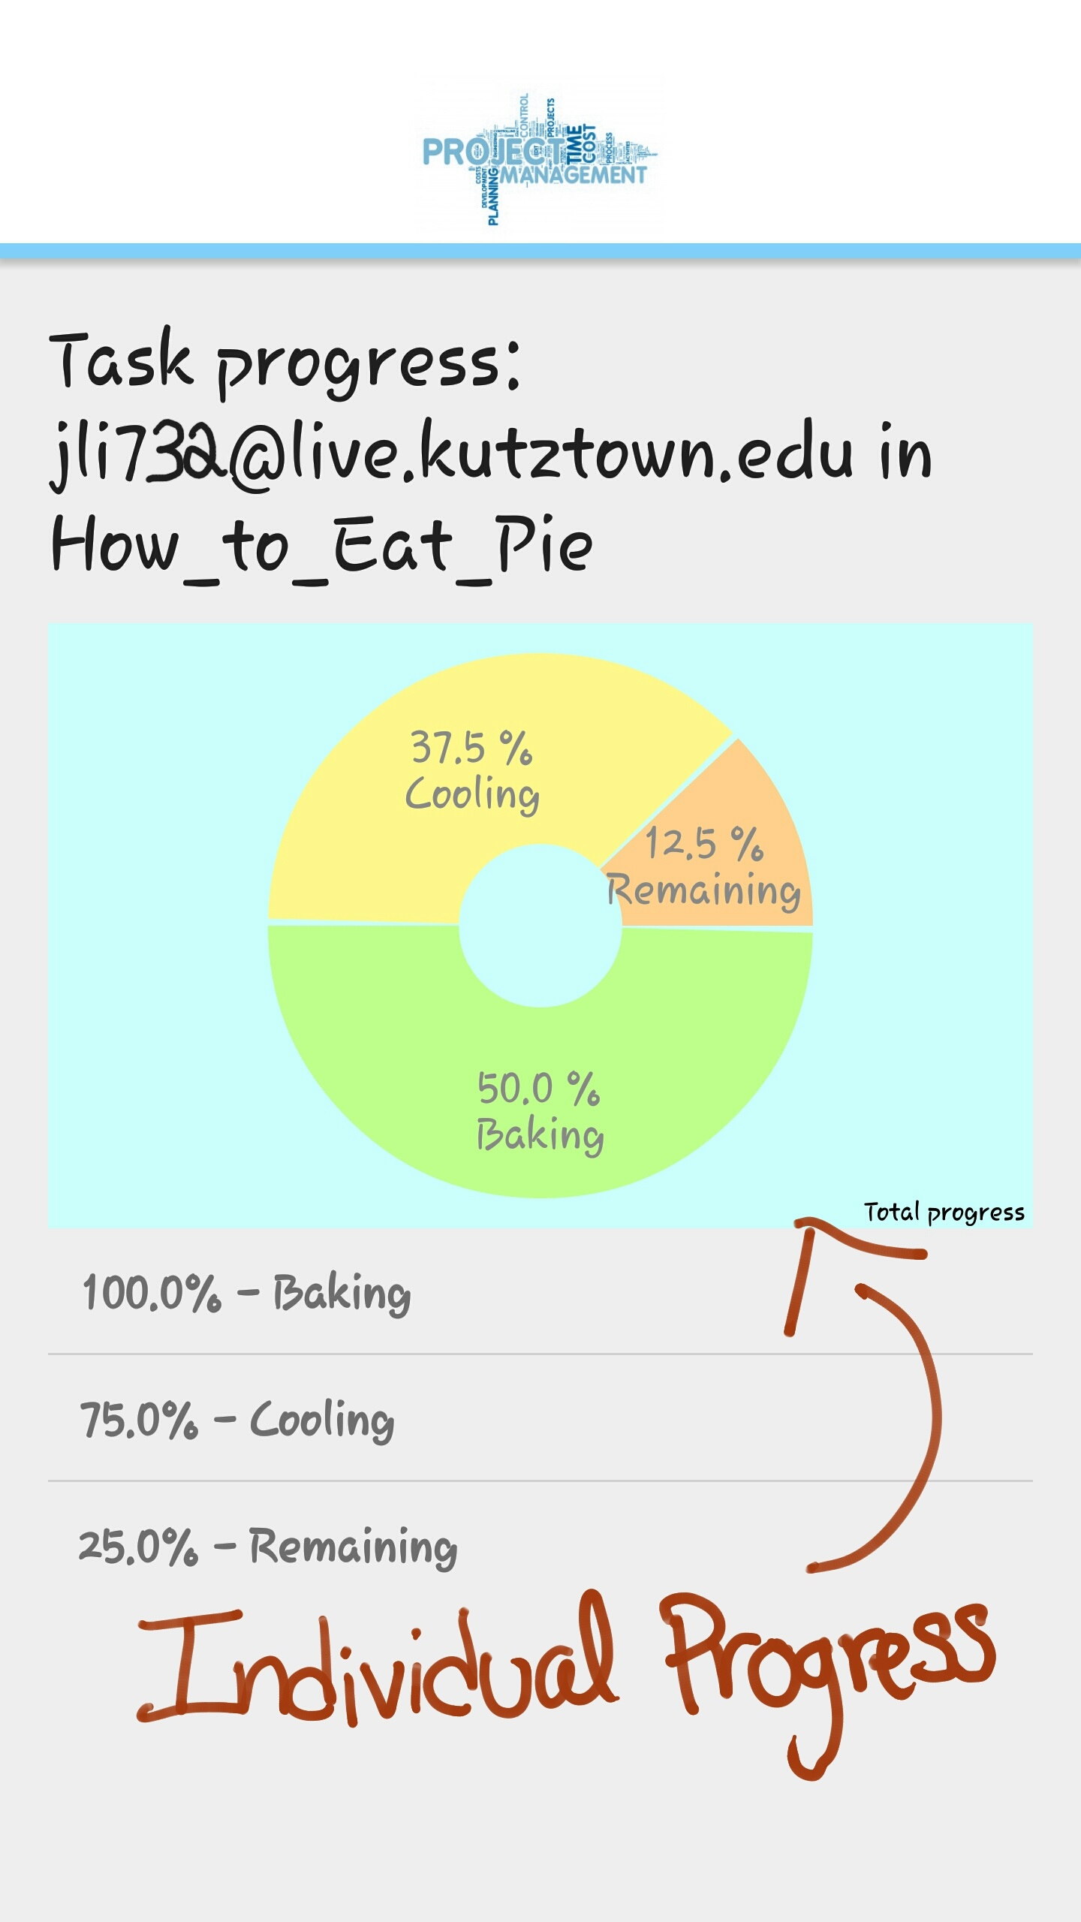

Image 18: Individual progress of a specific member of the project

**3.14 Choose a Role**

To choose a role in the Project Management app you have to fill out your profile, hit the “  ” and then select the “Profile” option from the dropdown menu. You will then be directed to the profile screen where you fill out all of the available fields as shown in image 19. Once done hit the “UPDATE” button at the bottom right hand corner.

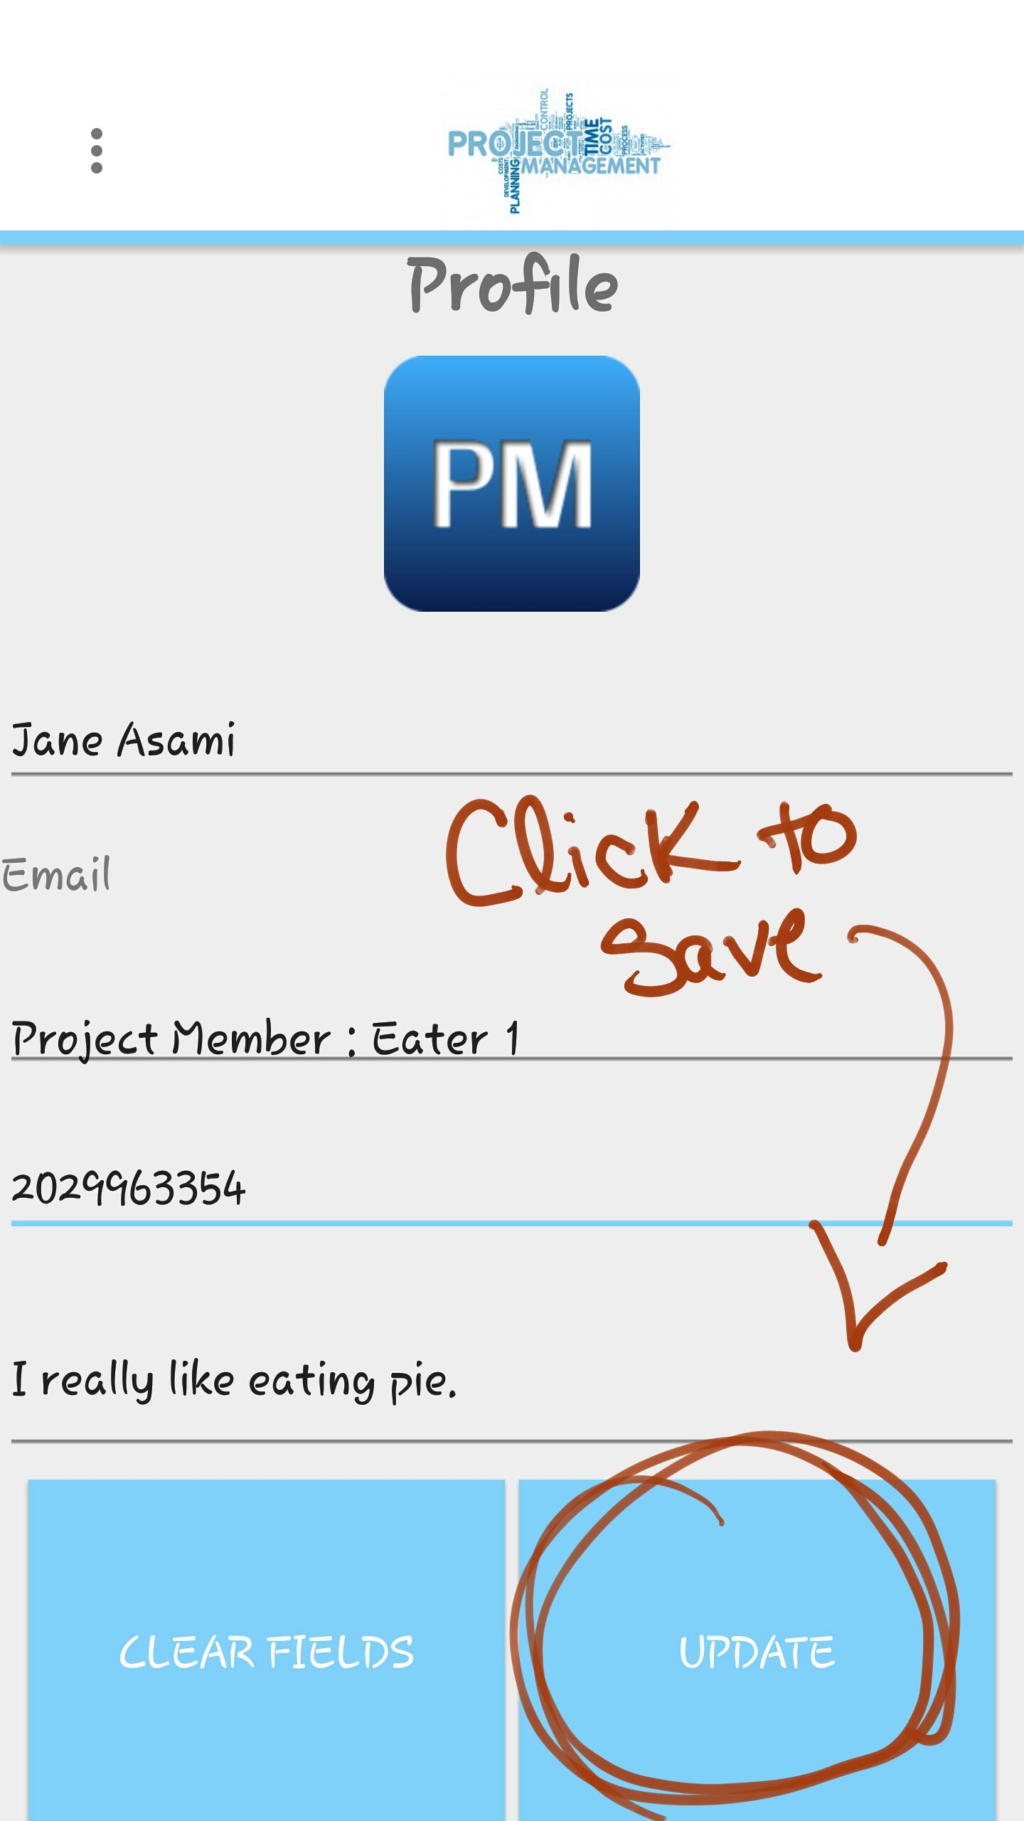

Image 19: Member Jane has filled her profile and given herself a role

**3.15 Set a Reminder**

This functionality has not been fully implemented yet.

**3.16 Message a Member**

To message a member of the specific project you must be logged in and be a part of a created project. Once those requirements are met, Click the “MESSAGING” button at the middle left hand side in the project view screen. Once clicked, you will be directed to the messaging screen as shown in image 21.

This functionality has not been fully implemented yet.

**3.17 Logout**

To logout of the Project Management app, hit the “  ” and then select the “Logout” option from the dropdown menu as shown in image 22.

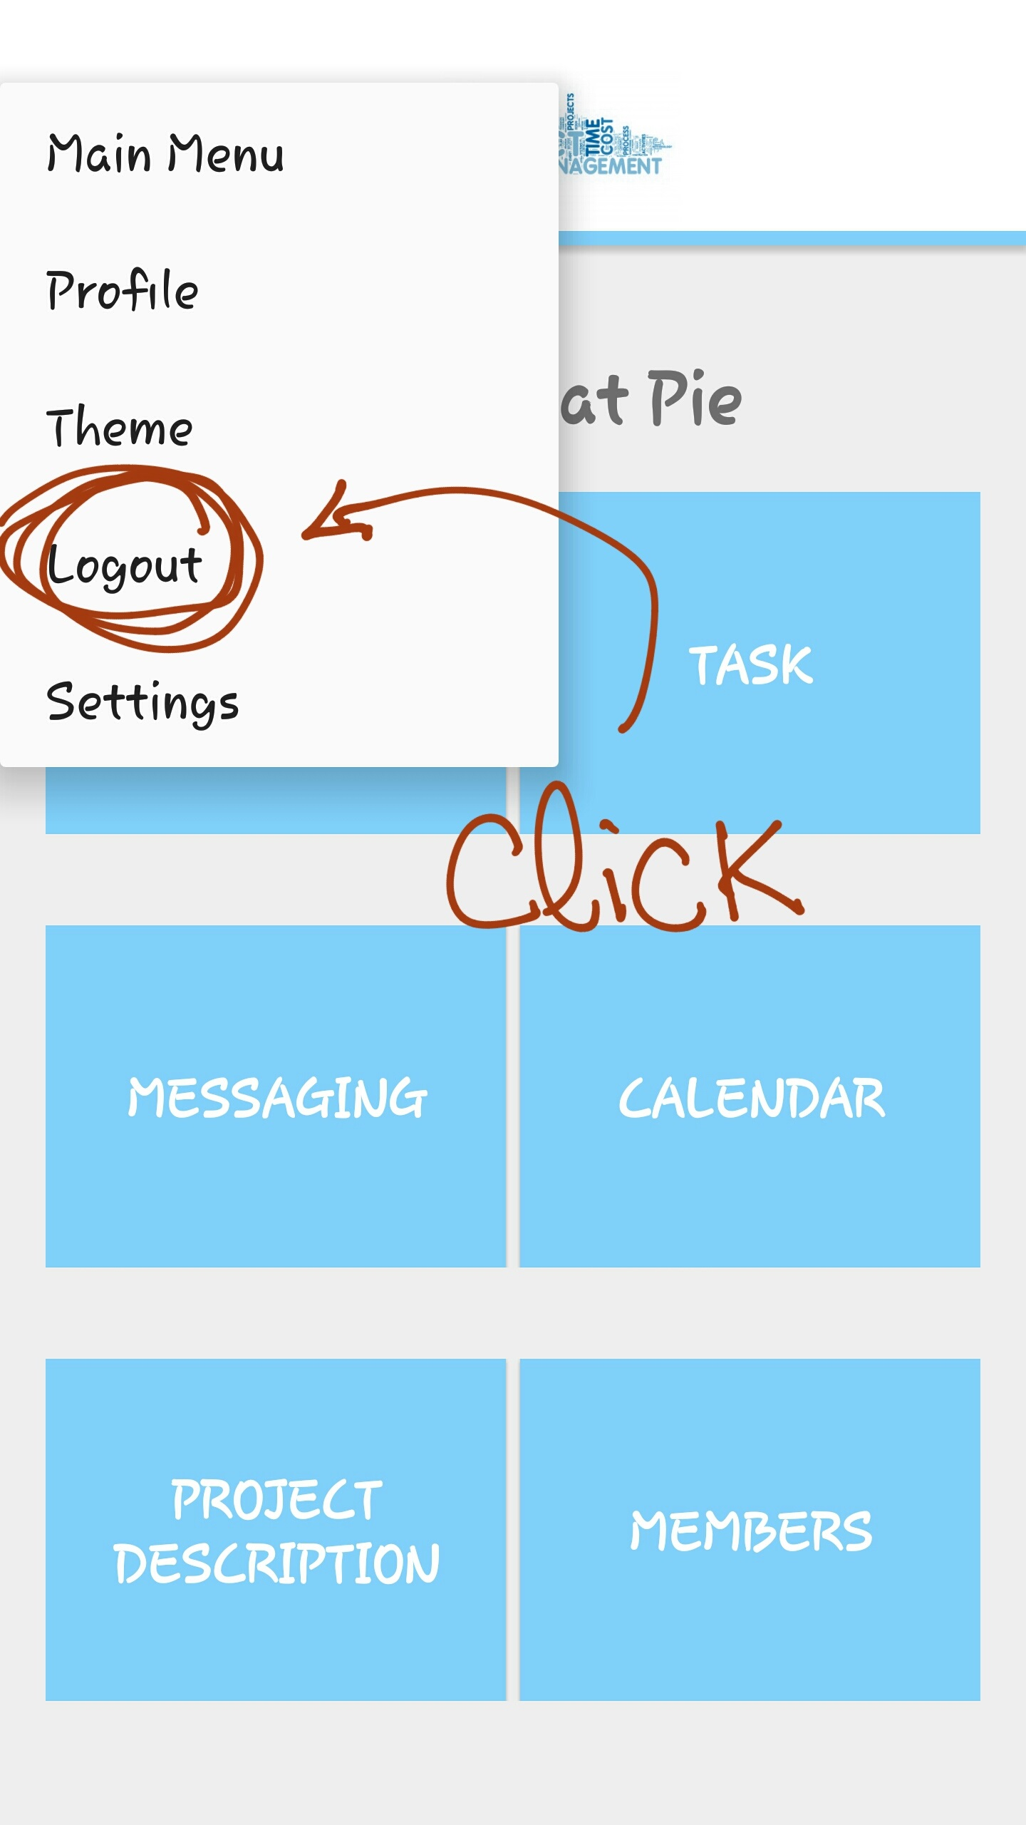

Image 22: The Logout option in the dropdown menu